Student Nurses

General Outpatient Department

General Outpatient Department

The General Outpatient Department sees patients from a rage of specialties in medical, surgical and nurse led clinics. Such as, renal, oncology, endocrinology, diabetes, general surgery, gynaecology and pre-assessment. We also have specialty departments such as fracture clinic/ orthopaedic outpatient department, ophthalmology, ENT, plastics outpatients and cardiology outpatients. These specialty areas are located outside of the general outpatient department and you will be shown where to go. You may also refer to the Hutt Hospital campus map on page 5.

Outpatients can be a foreign environment for students who sometimes feel a little “lost” or unsure of what’s going on. If you are feeling unsure please ask any of the team or speak with your lead preceptor.

Clinic’s run for either a half day or full day which is why some days you will be in two specialties. The list of objectives on pages 8-15 is to provide you with an idea of what you could learn from each clinic, this is by no means an exhaustive list. This orientation guide aims to provide you with the information you need to get the most out of your time with us.

Welcome!!
We are looking forward to working with you!

Contacts

General Outpatient Department |  | 570 9043
Clinical Nurse Manager (CNM) | Angeline Upchurch | 570 9364 | Angeline.upchurch@huttvalleydhb.org.nz
Associate Clinical Nurse Manager (ACNM) | Mair Richards | 570 9459 | Mair.richards@huttvalleydhb.org.nz
Lead Preceptor | Samantha Carter-Dean | 587 2825 | Samantha.carter@huttvalleydhb.org.nz

Samantha Carter-Dean is overall responsible for your placement in the department. Your preceptors will feedback your progress to the lead preceptor. Samantha will book you into relevant clinics and organise your roster for your time with us.

Your Preceptor

You will be allocated a preceptor in each clinic you are working in. Due to the nature of outpatients you will have multiple preceptors throughout your time. This preceptor will be responsible for completing your daily feedback form. It is your responsibility to ensure the nurse you are working with is aware of your objectives for the day/ clinic.

The lead preceptor will be responsible for completing your competencies in the last week of your placement. You must provide competencies and/ or other paperwork by the first day of your final week to ensure these can be returned to you before you finish. The lead preceptor will not complete any evaluations if you give it to them on your last days in the department.

If you have any concerns or questions do not hesitate to contact Angeline, Mair or Samantha.

Your Roster
Please contact Samantha for your roster.

 | Mon | Tues | Wed | Thurs | Fri
Week One

AM

PM
Week Two

AM

PM
Week Three

AM

PM
(The nurses listed may change slightly due to sickness or acuity but the clinic will remain the same).
See Hutt Hospital Campus map for locations – please ask reception if unsure of location.

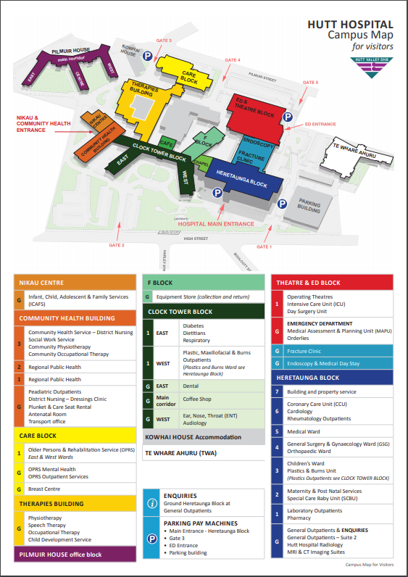

Expectations of the Student Nurse while in OPD

The clinics in General Outpatients are:

Morning | : | 0800hrs to 1200hrs
Afternoon | : | 1230hrs to 1630hrs

If your start/ finish time varies from this it will be noted on your timetable. Sometimes the morning clinic may run late or the afternoon clinic may start early/ late. Please ensure you discuss break times with you preceptor for your clinic. This is especially important if you are with two different preceptors that day as you are expected to have a 30 minute lunch break plus morning/ afternoon tea breaks.

We have a few expectations of student nurses working in the unit:

- It is expected that you arrive on time for your shift and if you are going to be late or you are unwell and cannot come to call the department on 570 9043.
- You must complete the full shift that you are allocated to work – if you are unable to do so please discuss this with your nurse, lead preceptor or nurse manager.
- It is important for your preceptor or the nurse you are working with to be aware of your objectives.
- Due to infection control a clean uniform must be worn, long hair must be tied back and cardigans must not be worn when working on the floor.
- If you are not achieving your objectives please see your lead preceptor (before the last week in the unit).
- Please ensure all documentation you need to complete for the polytechnic/ university is accomplished before the last days in the unit – your preceptor will not complete any paperwork that is given to them if it is given in the last days of your placement.
- Please complete the following form and return to Samantha or a senior nurse on your first day of placement.

Student Contact Details for General Outpatient Department

Contact details
The nurses in the department care about your well-being as well as your education. They will notice and be concerned if you don’t arrive for a planned shift, or may need to contact you if there is illness in the department or in the case of an emergency. They may need to contact you to check you’re okay and to let you know if there needs to be a change to your roster.
Your Name

Your Home
phone number
Your mobile
phone number
Name of emergency
contact & relationship
Phone number
of emergency contact
Please could you provide the ward with your contact details and an emergency contact using the form below? This information will be kept by a senior nurse for the length of this placement and then will be destroyed. It will not be shared with anyone else without your permission unless there is an emergency.

Contacting your Tutor/CTA
From time to time the staff in the department may need to contact your tutor regarding your progress, for support or in the case of problems.
Please could you supply the contact details for the tutor/CTA that will be supporting you during this placement, in the form below?
Name of Tutor/CTA

Phone number for Tutor/CTA

Please complete a new form before each new placement and give it to the senior nursing staff at the beginning of your placement.

Thank you

Objectives
These are examples of learning objectives relevant to each of the clinics you may be attending. Please note this varies with each roster. This is in no way an exhaustive list of the topics/ conditions/ procedures but will give you an idea for objectives for each day/ clinic. You may not always be able to observe the procedures but please check with your preceptor on the day.

Early Pregnancy Assessment Clinic
- Topics
  - Multi-disciplinary team approach to health care
  - Discussing sensitive news
  - Miscarriage
  - Ectopic pregnancy
  - Vaccinations during pregnancy

General Surgery Clinic
- Topics
  - What does general surgery cover?
  - Anatomy of the abdomen
  - Function of liver, bowel, spleen, thyroid, gall bladder, pancreas

- Common presentations
  - Hernia – inguinal, surgical, umbilical
  - Haemorrhoids
  - Cholecystitis
  - Lipoma

- Procedures/ Interventions
  - Haemorrhoid banding
  - Lipoma excision

Gynaecology Clinic
- Topics
  - Anatomy of the female reproductive system
  - What happens during menstruation

- Common presentations
  - Menorrhagia
  - Endometriosis
  - Prolapse
  - Cervical cell changes
- Procedures/ Interventions
  - Mirena insertion
  - Pessary insertion
  - Colposcopy

Podiatry Clinic
- Topics
  - Anatomy of the foot
  - Anatomy of the skin
  - How diabetes affects feet

- Common presentations
  - Charcot foot
  - Diabetic ulcers
  - Amputation
  - Ischaemic foot changes

- Procedures/ Interventions
  - Wound debridement and management
  - Wound dressings
  - Vascular and neurological assessments

Plastics Outpatients
- Topics
  - Wound healing
  - Aseptic technique
  - Causes of skin cancer

- Common presentations
  - Skin cancer
    - Melanoma, SCC, BCC
  - Post-op wound care

- Procedures/ Interventions
  - Wound care
    - Types of dressings used
  - Minor surgical procedures
    - Involvement of nurse in this setting
    - Equipment used
    - Informed consent

Diabetes Clinic
- Topics
  - Difference between type 1 and type 2 diabetes
  - Blood sugar levels/ HbA1c
  - Treatment
  - Causes

- Common presentations
  - Type 1 diabetes
  - Type 2 diabetes
  - Diabetic ketoacidosis

- Procedures/ Interventions
  - HbA1c testing
  - Blood sugar testing – finger prick

Pre-assessment Clinic
- Topics
  - Aspects of assessment covered in the pre-operative setting
  - Anaesthetics and the different assessments required
    - General anaesthetic, local anaesthetic, sedation
    - Pre-operative testing
    - Process when a patient is unfit to proceed to surgery/ anaesthetic

- Procedures/ Interventions
  - Vital signs
  - Electrocardiogram (ECG)
  - BMI

Haematology Clinic
- Topics
  - Coagulation
  - Red and white blood cells

- Common presentations
  - Multiple Myeloma
  - Haemochromatosis
  - Bleeding and thrombosis disorders
  - Hodgkin’s/ Non-Hodgkin’s Lymphoma
  - Chronic neutropaenia

Clinical Nurse Coordinator
- Topics
  - Process for a patient from GP referral to theatre
  - Surgical waiting lists
  - How a theatre list is developed
  - What prevents a patient from proceeding to surgery within the expected timeframes
Dermatology Clinic
- Topics
  - Skin anatomy

- Common presentations
  - Tinea
  - Acne
  - Eczema
  - Psoriasis
  - Dermatitis

- Procedures/ Interventions
  - Punch biopsy
  - Liquid Nitrogen Treatment

Fracture Clinic
- Topics
  - Bone anatomy
  - Types of fracture
  - Types of imaging and their uses

- Common presentations
  - Acute injury/ fracture
  - Osteoarthritis
  - Talipes (club foot)

- Procedures/ Interventions
  - Wound care
    - Aseptic technique
    - Types of dressings
  - Casting
  - Manipulations of dislocation

Endocrine Clinic
- Topics
  - What is the endocrine system
  - How does the endocrine system work
  - What organs are involved in the endocrine system

- Common presentations
  - Thyroid disorders
  - Transgender
  - Acromegaly

- Procedures/ Interventions
  - Intra-muscular injection

Cardiology Clinic
- Topics
  - Anatomy of the heart
  - Circulatory system

- Common presentations
  - Atrial fibrillation
  - Murmur
  - Congenital heart defect
  - Myocardial infarction (heart attack)

- Procedures/ Interventions
  - Echocardiogram
  - Treadmill test
  - Cardiac rehabilitation

Respiratory Clinic
- Topics
  - Inhaler therapy
  - Oxygen therapy

- Common presentations
  - COPD
  - Asthma
  - Emphysema

- Procedures/ interventions
  - Lung function tests
  - Pulmonary rehabilitation
  - Community exercise classes

Renal Clinic
- Topics
  - Anatomy of a kidney
  - Function of a kidney
  - Common disease to affect kidney function

- Common presentations
  - Chronic kidney disease
    - Stages 1- 5
  - Renal transplant

Ear, Nose and Throat (ENT) Clinic
- Topics
  - Tonsillitis
  - Otitis media
  - Ventilation tubes/ grommets
  - Adenoid Hypertrophy
  - Tympanic membrane perforation
Ophthalmology (eye) Clinic
- Topics
  - Anatomy of the eye

- Common presentations
  - Cataract
  - Glaucoma
  - Macular Degeneration

Evaluation of your Clinical Preceptors
Cut long line
------------------------------------------------------------------------------------------------------------------------------------------------------------------------------------------------------------------------------------------------------------------------------
Please return your evaluation to Samantha (Lead Preceptor)

Please complete table as an average across all your preceptors and identify any specifics highlights/ issues in the written area below.

Date__________
E = Excellent VG = Very Good S = Satisfactory NI = Needs Improvement

Please read the following statements then tick the box that best indicates your experience
My Preceptor: | E | VG | S | NI
Was welcoming and expecting me on the first day

Was a good role model and demonstrated safe and competent clinical practice

Was approachable and supportive

Acknowledged my previous life skills and knowledge

Provided me with feedback in relation to my clinical development

Provided me with formal and informal learning opportunities

Applied adult teaching principals when teaching in the clinical environment

Describe what your preceptors did well

Describe anything you would like done differently

Signed:____________________________ Name:_____________________

