2019-20

2
Student Information Booklet

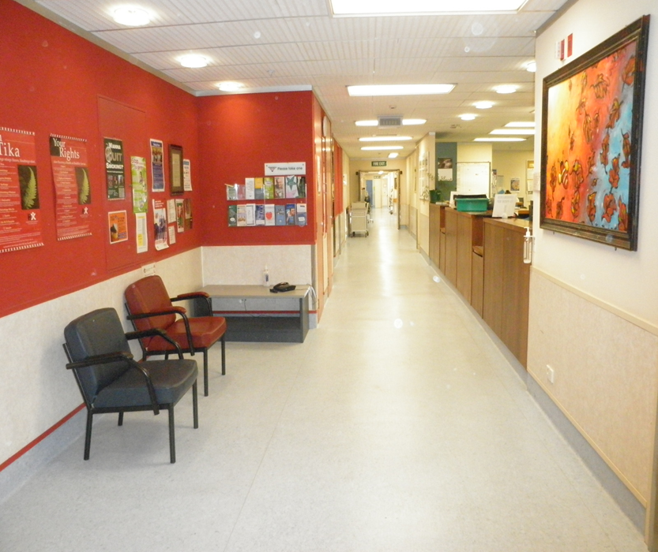

ACUTE MEDICAL WARD
Contact Number: 04 570 9039


Welcome to the Acute Medical Ward at the Hutt Valley District Health Board.
We hope you find your placement a valuable and enjoyable learning experience.

Contact Information
Medical Ward -  Medical Ward Clerks | Eileen Winter Ellison Martin Lyn Amies Liz McCloat | DD 04 570 9039
Clinical Nurse Educator (CNE) | Eleanor Clark | DD 04 570 9074 Page: 701
Associate Clinical Nurse Managers (ACNM) | Ingrid Baas, Jaqui Dyne, Kate Nolan, Rose Curato, Michaela O’Neil, Karen Wiggins, Loyis Edwin | DD 04 570 9050
(Acting) Clinical Nurse Manager (CNM) | Jenny Keene
Duty Managers (DM) | Debbie, Chris, Jenny, Janet, Margaret, Nathan, Theresa, Theresa, Sarah | 04 5666 999 Ask for the Medical Duty Manager
Fax Number for the Medical Ward |  | 04 5709263

Student Contact details

The staff on the ward/department care about your well-being as well as your education. They will notice and be concerned if you don’t arrive for a planned shift, if there is illness on the ward or in the case of an emergency. They may need to contact you to check you’re ok and to let you know if there needs to be a change to your shifts.
Please could you provide the ward with your contact details and an emergency contact using the form below? This information will be kept by a senior staff member for the length of this placement and then will be destroyed. It will not be shared with anyone else without your permission unless there is an emergency.
Name: | Home Tel. No:  Mobile Tel. No:
Name of Emergency Contact: | Home Tel. No:  Mobile Tel. No:

Contacting your Tutor/CTA

From time to time the staff on the ward may need to contact your tutor regarding your progress, for support or in the case of problems.
Please could you supply the contact details for the tutor/CTA that will be supporting you during this placement, in the form below?
Name of Tutor / CTA : | Contact No. for Tutor / CTA :

Please complete a new form before each new placement and give it to the senior staff at the beginning of your placement.
The Acute Medical Ward
The Acute Medical Ward is part of the Hutt Valley District Health Board which serves a population of approximately 146,000.
It is situated on the 5th floor of the Heretaunga Block and has 54 beds which incorporates a stroke unit, a close observation bay and 2 beds for patients requiring BiPAP. Patients are admitted with a variety of medical conditions.
The Medical Ward receives patients primarily from ED, MAPU, ICU, CCU and the Endoscopy Unit.

Shift Timings on the Medical Ward
AM Shift: 0700- 1530
PM Shift: 1445- 2315
Nocte Shift: 2245- 0715
Swipe Cards are not available to students. Your preceptor will provide you with access to the drug and staff room. If the main doors to the ward are locked, please press the bell and wait to be let in.
There is a coded locked cloakroom next to the staffroom for your personal belongings. The safety of all these items depends on the door being closed when leaving the room.
Please ensure you do this, thank you.
The staff room has a fridge/freezer for personal use and free coffee and tea facilities. Please wash up any crockery or cutlery that you use yourself.

Placements
Your placement is an excellent opportunity to consolidate your knowledge that you have gained in the Nursing School. We acknowledge this commitment to your learning and will support this. Please feel free to ask any questions.
If at any point during your placement you are feeling overwhelmed or have other difficulties, your first point of contact would be your preceptor. If you need further help, contact Eleanor Clark, Clinical Nurse Educator or the ACNM/ Shift Co-ordinator.

We have a few expectations of student nurses working in the Medical unit
- It is expected that you arrive on time for your shift and if you are going to be late or you are unwell and cannot come to work , call the unit 04 570 9039
- You must complete the full shift that you are allocated to work – if you are unable to do so please discuss this with your preceptor or nurse educator. A lot of learning occurs at quiet times in the unit!!
- Due to infection control a clean uniform must be worn, long hair must be tied back and cardigans must not be worn when working in the floor. No jewellery except wedding ring. Please wear a name badge all the time.
- It is important for your preceptor or the nurse you are working with that he/she is aware of your objectives
- If you are not achieving your objectives please discuss this with your preceptor and /or the Clinical Nurse Educator (CNE), Eleanor Clark as soon as possible. Please do not wait until the last week.
- Please ensure all documentation you need to complete for the polytechnic/university is accomplished before the last days in the unit – your preceptor/s are not obligated to complete any paper that is given to him or her if it is given in the last days of your placement.
- Please familiarize yourself with the fire exits and layout of the ward. If a fire alarm sounds, please follow the instructions of the fire warden. They are a member of staff wearing a yellow visibility jacket. They will hand out cards with instructions on to be completed. Please work with your preceptor to complete the task and report to fire warden that it has been completed.

Admissions to the Acute Medical Ward
The Duty Managers inform the ACNM’s of patients requiring a Medical / Stroke Bed. On acceptance, the patient is allocated to a RN dependant on workload and experience.
The patients are usually admitted by a different rotating Medical ‘team of the day’. All Medical teams comprise of a Consultant Physician, Registrars and House Surgeons There are several Medical Teams, each headed by different Consultants. They review their allocated patients between from 08:00 to 16:00, Monday to Friday. There is a rotational team on the weekends who review patients admitted on the previous evening or night. After 16:00 there is a Spade referral service which requests a Doctor to review patients in order of urgency. This service is used in conjunction with the 777 Medical Emergency protocols.
There is also a paging system to contact Doctors during all shifts – your preceptor will explain how and when to use this.
Visitors
We have 2 dayrooms – one each end of the ward. There is a small kitchenette next to these which the families can help themselves to drinks provided. They may use the milk from the fridge but no other food or drinks as these are for the patients. They may use the toilet outside the ward only.
Family members may stay with a patient overnight but this must have permission from the ACNM / Coordinator. We prefer 2 patients at a bedside at one time and encourage the families to rotate visitors for large families by using the dayroom; this is to support the well-being of the other patients.
There may be times when it is appropriate to ask the visitors to leave e.g. for personal cares or after 20:30 when the ward closes to all those not staying overnight. Support for managing this should be sought from your preceptor or ACNM / Coordinator. It is important to be culturally and spiritually mindful in these situations.

Learning Objectives
The following are some examples of some learning objectives that you may have, but this is not an exhaustive list of the knowledge or skills that you can develop whilst on your placement in the Medical ward:
- Observation, listening and communication skills
- The provision of appropriate care to the patient and Whanau and the professional, ethical and legal responsibilities this involves.
- Accurate assessment including Early Warning Score, Risk assessment forms like falls risk, Skin integrity.
- Vital and neurological observations
- Competent implementation of care e.g. pressure injury prevention
- Time Management
- Documentation / Handover skills
- Referrals
- Gain an understanding of the multidisciplinary team approach to care and the type of work involved e.gs. Doctors, Dietician, Social worker, Physiotherapist, Occupational therapist, Speech and language therapist, Diabetes Clinical Nurse Specialist, Palliative Clinical Nurse Specialist, Stoma Clinical Nurse Specialist, Respiratory Nurse Specialist, Maori Health Unit, Pacific Health Unit, Interpreter Services, Chaplain / Priest, PAR Nurse.
- Practice correct infection control measures
- Fluid management/Fluid balance
- Wound management.
- Completing an ECG – recognizing basic rhythms e.g. NSR, AF
- Observe Clinical Device Management skills e.gs. suction, use of oxygen and air, IVC, PICC, CVL, syringe drivers, chest drains, VAC therapy, humified oxygen (oxygen), BiPAP, sub-cutaneous line, nasogastric tube / feeding, indwelling catheter, stomas, faecal management systems
- Observation / Learning the benefits from procedures e.gs. X-ray, CT, MRI, Fluoroscopy, blood results, oxygen therapy.
- Familiarisation with the computer software program – Trendcare. It is highly likely to be part of your future clinical practice.

Common Presentations in the Medical ward
- Stroke – Ischemic and Hemorrhagic stroke
- TIA
- Exacerbation of COPD / Asthma
- Diabetes Mellitus – Type 1 and 2
- Cellulitis
- Pneumonia
- Sepsis
- Acute Kidney Injury
- Crohn’s Disease, Inflammatory Bowel Disease
- Delirium
- Dementia
- Multifactorial i.e. age-related social issues requiring multi-disciplinary assessments
- Fractured pubic rami
- Te Ara Whakapiri – end of life pathway
- Post PEG insertion (percutaneous endoscopic gastrostomy)

Common Medications
The following are some medication groups that you may commonly come across in the Medical Ward:
- Antihypertensives e.g. metoprolol, amlodopine
- Anticoagulants e.g. warfarin
- Antiplatelet e.g. aspirin
- Diuretics e.g. frusemide
- Insulin e.g. protaphane, novorapid
- Bronchodilators and different inhalers e.g salbutamol, ipratropium
- Analgesia e.g. paracetamol, fentanyl, morphine

Notes:

Treasure Hunt
This list is designed to help you become familiar with the environment, but is by no means exhaustive of all the things you will be required to locate.

 | Oxygen and Air flowmeters |  | Resuscitation Trolley
 | Dangerous Drug cupboard |  | Clinical policies & procedures
 | Treatment Room |  | “Notes on Injectable Drugs”
 | Linen supplies |  | Roster
 | Clinical Nurse Manager Office |  | Manual BP machine
 | Senior Staff Office |  | Suction Equipment
 | IV Syringes |  | Bio-hazard bags
 | Where to store your bags |  | Tympanic thermometer covers
 | Staff tea room |  | Fire extinguisher
 | Staff toilets (x2) |  | Photocopier
 | X-ray facilities |  | Patient Observation Charts
 | Clean utility room |  | Laboratory forms
 | Dressing Materials |  | ECG Machine
 | Distraction Trolley |  | Fire exit
 | Weighing scales(sitting) |  | Suction apparatus
 | Alcohol Swabs |  | Sterile Gloves
 | Nurse transfer form |  | Lamson Tube System
Evaluation of your Clinical Preceptor

Please return your evaluation to Angeline (Nurse Educator)

Name of Preceptor_____________________________________ Date__________
E = Excellent VG = Very Good S = Satisfactory NI = Needs Improvement

Please read the following statements then tick the box that best indicates your experience

My Preceptor: | E | VG | S | NI
Was welcoming and expecting me on the first day

Was a good role model and demonstrated safe and competent clinical practice

Was approachable and supportive

Acknowledged my previous life skills and knowledge

Provided me with feedback in relation to my clinical development

Provided me with formal and informal learning opportunities

Applied adult teaching principals when teaching in the clinical environment

Describe what your preceptor did well

Describe anything you would like done differently

Signed:____________________________ Name:__________________________
Common Abbreviations:
ED – Emergency Department
MAPU – Medical Assessment and Planning Unit
CCU – Coronary Care Unit
MDT – Multi-disciplinary Unit
IDC – Indwelling Catheter
SPC – Suprapubic catheter
S/C – Subcutaneous Catheter
IVC – Intravenous cannula
PICC – peripherally inserted central catheter
CVL – Central Venous Line
VAC – vacuum assisted closure
BiPAP – Bi-level positive airway pressure
NGT – Nasogastric tube
CT – Computerised Topography
MRI - Magnetic Resonance Imaging
PAR (Nurse) – Patient at risk
Additional:

